WEEK 7 ASSIGNMENT PROBLEMS (LINEAR PROGRAMMING)

Problem 1
The logistics/operations manager of a mail order house purchases two products for resale: King Beds (X) and Queen Beds (Y). Each King Bed costs $500 and requires 100 cubic feet of storage space, and each Queen Bed costs $300 and requires 90 cubic feet of storage space. The manager has $75,000 to invest in beds this week, and her warehouse has 18,000 cubic feet available for storage. Profit for each King Bed is $300 and for each Queen Bed is $150. The objective is to maximize profits. Convert this word problem into an LP model and then SOLVE it using the graphical solution method.

Note: You MUST solve Problem 1 using the graphical solution method and show all the algebra to receive full credit (An example of the graphical solution method was emailed to you last week).

Solution
The objective function
Profit maximization, Z = $300x + $150y

Subject to Constraints
100x + 90y ≤ 18,000 ………………………..s1
\500x+300y ≤ 75000 ……………………….s2
x , y $≥0$ …………………………………….s3

solution
100x+90y =18000 Equation 1 derived from constaint 1
x | 0 | 180
y | 200 | 0

When x=0
100(0)+90y=18000
Y=18000/90
Y=200
When y=0
100x+90(0)=18000
X=18000/100
X=180
500x+300y= 75000 Equation 2 derived from constraint 2
x | 0 | 150
y | 250 | 0
When x=0
500(0)+300y=75000
Y=75000/300
Y=250
When y=0
500x+300(0)=75000
X=75000/500
X=150

Using graphical method
The optimum point in the feasible region represents regions A (0,0) B(150,0) , C(105,90) and D (0,200)
The profit maximization is given by
Z = $300x + $150y
Profit at A= 300(0)+150(0)
=0
Profit at B (300$×150)+150(0)$=45000
Profit at C (300 $×105+150×90=45000$
Profit at D 300(0)+150$×200=30000$
Therefore, point B is is where maximum profit is derived of $ 45,000
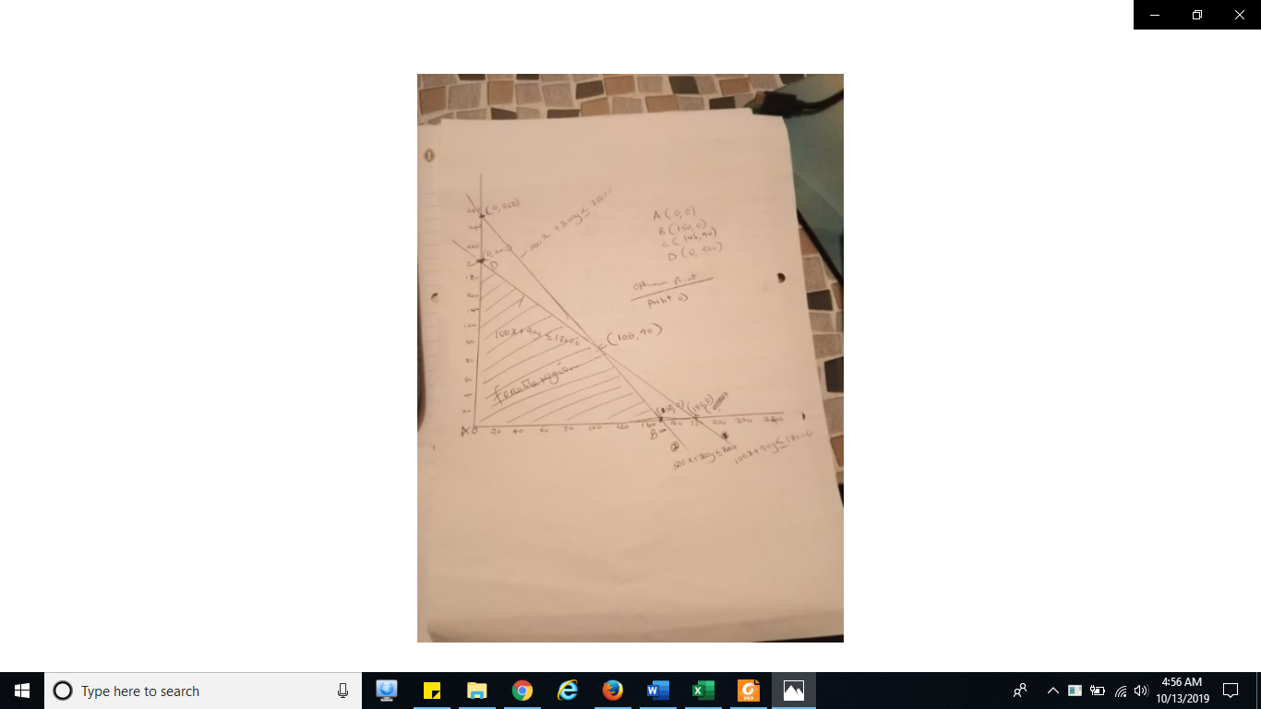

Problem 2
The manager of the deli section of a grocery superstore has just learned that the department has 112 pounds of mayonnaise, of which 70 pounds is approaching its expiration date and must be used. To use up the mayonnaise, the manager has decided to prepare two items: a ham spread and a deli spread. Each pan of the ham spread will require 2.8 pounds of mayonnaise, and each pan of the deli spread will require 2.0 pounds. The manager has received an order for 10 pans of ham spread and 8 pans of the deli spread. In addition, the manager has decided to have at least 10 pans of each spread available for sale. Both spreads will cost $3 per pan to make, but ham spread sells for $6 per pan and deli spread sells for $7 per pan. Convert this word problem into an LP model.
Hint: Note that there are two objective functions. One would be where you maximize your profits. The other objective function is to minimize costs. The constraints remain the same for both objective functions. You will NOT be solving this problem. You will only be writing the LP model i.e., the objective functions and the set of all constraints.

Solutions
Objective function
Formulation
Decision variables
H – the number of pans of ham spread to make
D- the number of pans of deli spread to make
Objective function
Manimize z=3H+3D
Constraints
Mayo Min: 1.4H+D>70
Mayo Max: 1.4H+D<112
Ham min : H>20
Deli min : D >18
H, D >0

Slack and surplus variables
Standard form of a LP; stardard form requires all constraints to be the firm of equation
Constraints
1.4H+D-s1=70
14H+D+s2=112
H-s3=20
D-s4=18
H,D>0

